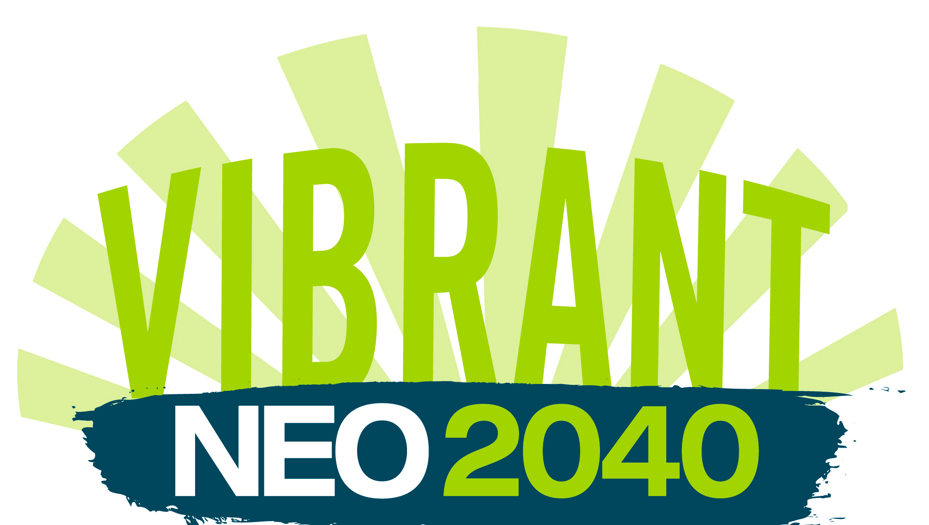 | PRESS RELEASE  For more information, contact:  Jeff Anderle  330-285-5372 (cell)  janderle@neoscc.org

NEOSCC announces schedule for regional Scenario Planning public work shops

The Northeast Ohio Sustainable Communities Consortium (NEOSCC) has announce the schedule and details for the first round of public workshops that will gather resident input about the values and priorities of this region.

These workshops are the first phase of a year-long VibrantNEO 2040 process, an effort by NEOSCC to create a more vibrant, sustainable, and resilient future for this region. This initial phase of the VibrantNEO 2040 process will focus on helping residents identify what choices can be made now that give the region the greatest chance for success in the future. To do this, NEOSCC is using a tool called Scenario Planning, which will look at potential futures for the region based on potential choices about land use and use of resources.

“The workshops have been scheduled to give as many people as possible a chance to participate,” SAID NEOSCC Executive Director Hunter Morrison. “Simply pick the location and day most convenient for you, RSVP if possible, and join us.”

During workshops, participants will learn how Northeast Ohio may look in the year 2040 if present trends continue and how those trends will affect current and future generations. They will also explore alternative futures together through map-drawing and gaming. The core questions that the sessions are designed to answer are: what are the most important issues and priorities to Northeast Ohio, and what should be considered to make Northeast Ohio more vibrant, resilient and sustainable?

Online registration for all workshops is available at the links below. Prior registration is not required but is encouraged. The April/May meetings begin at 6:30 pm (registration opens at 5:30) and will be located at the following locations:

April 30
The Oberlin Inn
7 North Main Street
Oberlin, OH 44074
http://tinyurl.com/VibrantNEO-Oberlin-043013

John F. Kennedy High School
2550 Central Pkwy Ave SE
Warren, OH 44484
http://tinyurl.com/VibrantNEO-Warren-043013

May 1
Third Federal Savings & Loan (Auditorium)
7007 Broadway Avenue
Cleveland, OH 44105
http://tinyurl.com/VibrantNEO-Cleveland-050113

The Metropolitan Centre
601 Cleveland Avenue NW
Canton, OH 44702
http://tinyurl.com/VibrantNEO-Canton-050113

May 2
Akron Urban League
440 Vernon Odom Boulevard
Akron, OH 44307
http://tinyurl.com/VibrantNEO-Akron-050213

Corporate College - East
4400 Richmond Road
Warrensville Heights, OH 44128
http://tinyurl.com/VibrantNEO-WH-050213

Two additional rounds of public workshops will be held later in the year in August and September. More details about those workshops will be available once they are confirmed.

About NEOSCC
NEOSCC is largely funded by a highly competitive, first-of-its kind, grant from the U.S. Department of Housing and Urban Development (HUD) as part of the new federal Sustainable Communities Initiative. The Sustainable Communities Initiative is an interagency collaboration among HUD, the U.S. Department of Transportation, and the U.S. Environmental Protection Agency. The Northeast Ohio Sustainable Communities Consortium (NEOSCC) is a three-year planning effort to revitalize the 12 counties that comprise Northeast Ohio. The effort includes 33 regional consortium members and more than 100 other organizations throughout the 12 counties. The Fund for our Economic Future also awarded NEOSCC a $500,000 matching program grant. Consortium member organizations pledged more than $2.35 million in staffing and operating expenses. To learn more, visit: http://vibrantneo.org/.

About the VibrantNEO Initiative
NEOSCC’s VibrantNEO Initiative focuses on advancing our 12-county region amidst today’s economic climate and stretched resources. Its goal is to increase the quality of life within our region; connect our communities; welcome diversity; restore and protect our natural resources; and create a competitive economic framework for the vitality of our region.

- 30 -

